**GTI SOFT INSTALATION**

1. Access folder of GTISoft by File Explorer \\10.62.2.3\lfsoftupgrade$

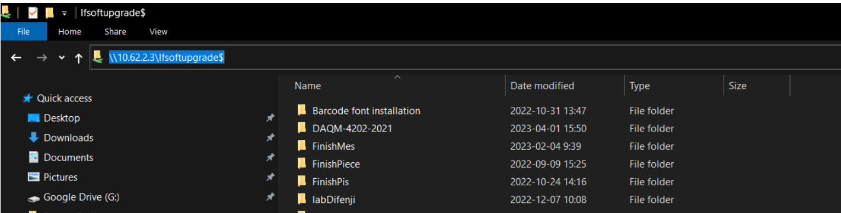

If asked to enter a password, enter the user : User and password : (empty) then press Enter

1. Install the Barcode Font Instalation first



Select all font, right click and install for all user.

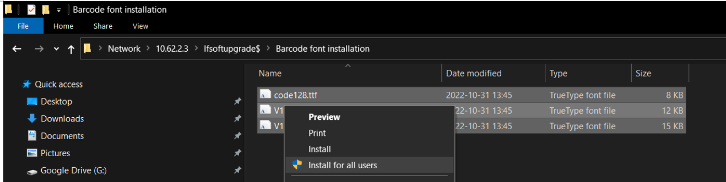

1. Go to [\\10.62.2.3\lfsoftupgrade$\SoftInstallList\CrystalReport](\\\\10.62.2.3\\lfsoftupgrade$\\SoftInstallList\\CrystalReport) and install CRRuntime_32bit_13_0_25.msi

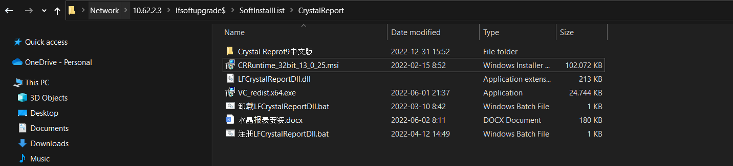

Install the application, follow the step until finish.

1. Go to [\\10.62.2.3\lfsoftupgrade$\SoftInstallList](\\\\10.62.2.3\\lfsoftupgrade$\\SoftInstallList) then copy folder GTISoft and paste to Drive D:\ of your local computer

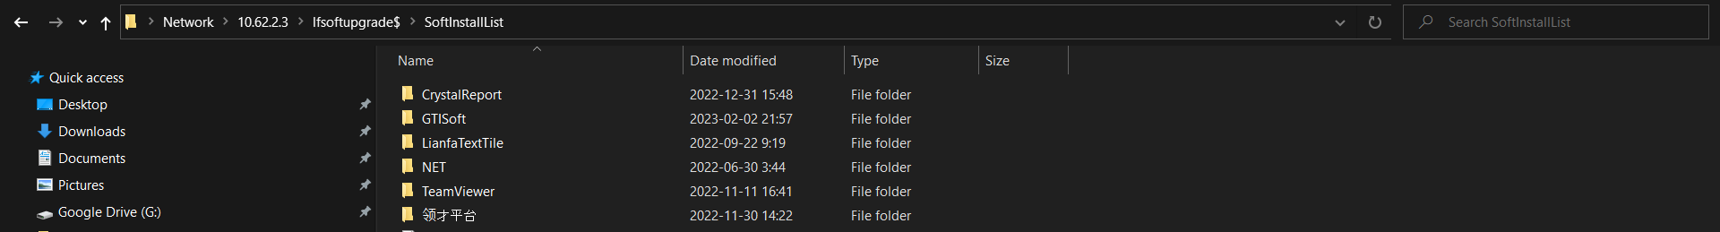

\

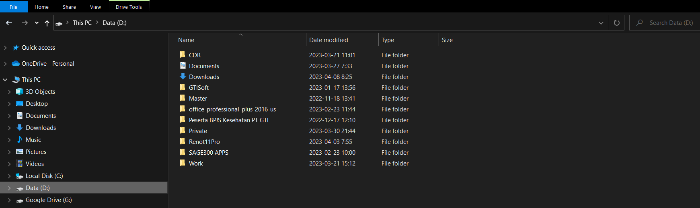

1. Go back to [\\10.62.2.3\lfsoftupgrade$\SoftInstallList\CrystalReport](\\\\10.62.2.3\\lfsoftupgrade$\\SoftInstallList\\CrystalReport) copy file like below and paste to folder GTIsoft on local Computer.



Just replace when ask

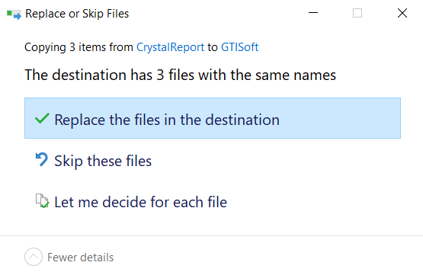

Register the file by double click on the file

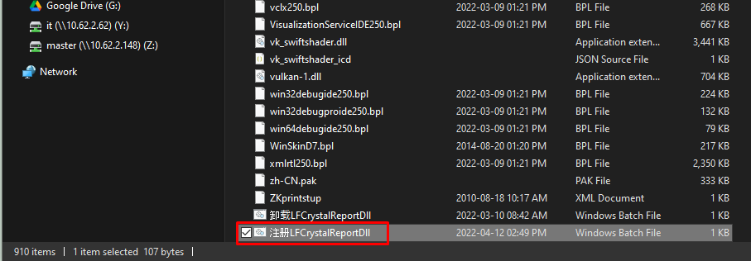

It will appear like below, and press any key to continue…

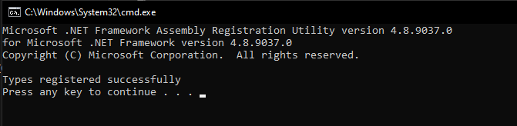

1. Go to [\\10.62.2.3\report$](\\\\10.62.2.3\\report$) and make sure the folder can be access. If there are a question to input username and password, just input for Username: ITADMIN Password : GTISoft

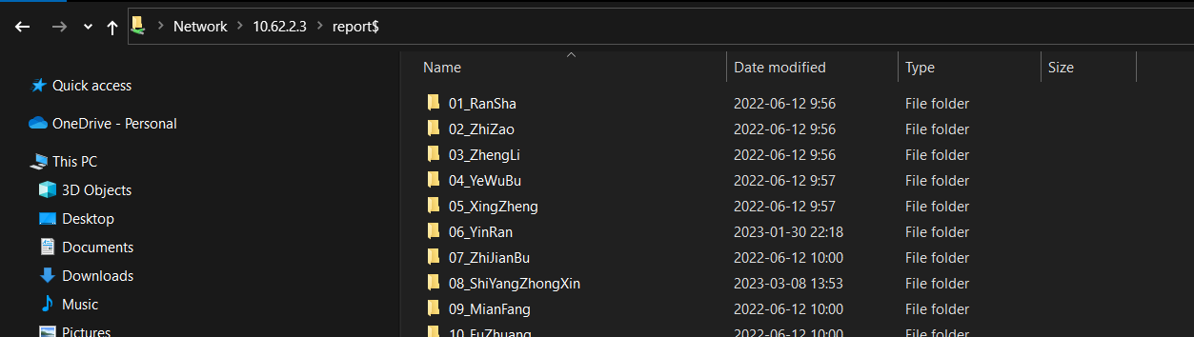

1. Go to Control Panel\Clock and Region and choose Region

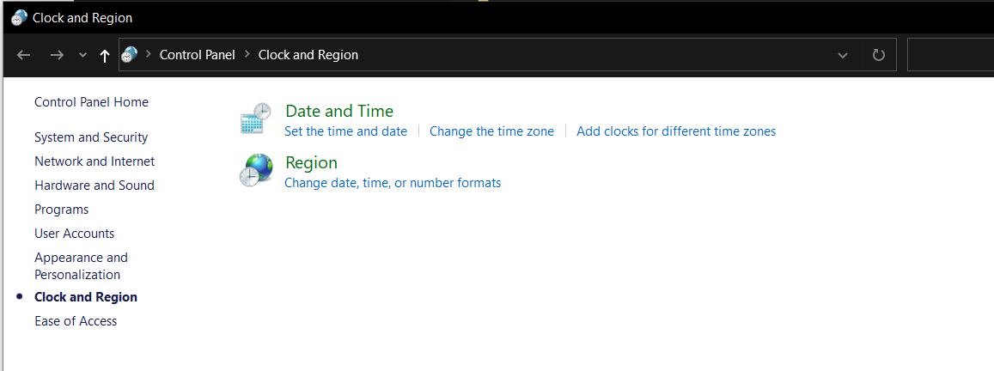

Go to Administrative and choose Change System Locale

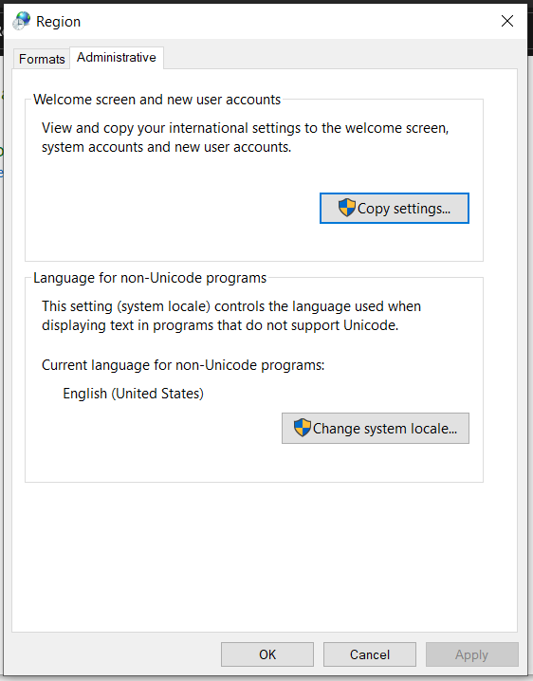

Change it to Chinese (Simplified, China) then OK and out

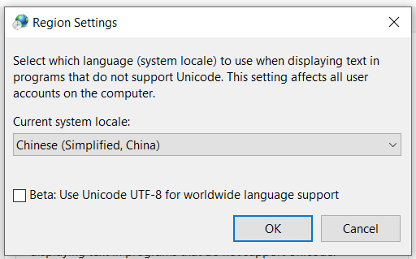

1. Now open GTISoft.exe from GTISoft folder that already on local Computer (Drive D:\)

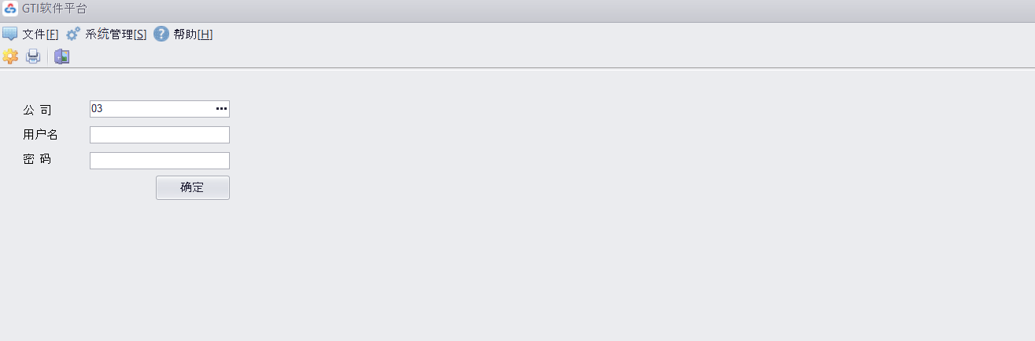

GTISoft ready to use